4850MP

JERZEES
Super Sweats
Sweatpants w/ pockets

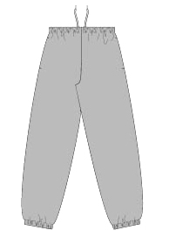

Descriptions
*50/ 50 cotton NuBlend fleece, 9.3 ounces
*Side entry bag pockets
*Double-needle stitched elastic waistband w/ interior drawcord
*Elastic cuffs
*Embroidery or Screenprinting okay

Finished Garment Measurements

Size | S | M | L | XL
Inseam | 31 ¾ | 32 ¼ | 32 ¾ | 33 ¼
Width | 13 | 14 | 15 | 16

