29B
JERZEES

Youth T-Shirt

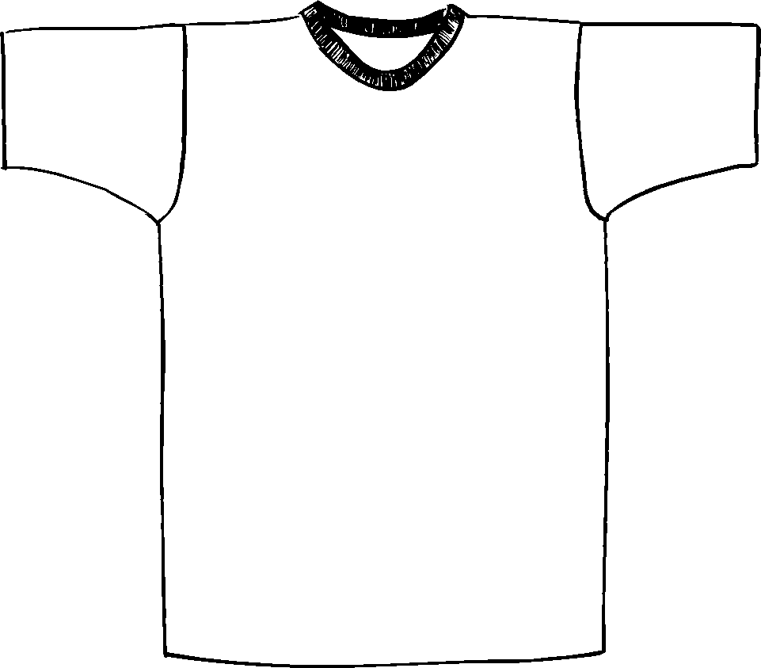

Description
*50/50 Poly cotton, 5.6 ounce
*20 singles
*Taped shoulder to shoulder
*Double needle sleeve & bottom hem
*Ribbed collar
*Embroidery or screenprinting okay

Finished Garment Measurements

Size | XS | S | M | L | XL
Width | 14 | 16 | 17 | 18 | 19
Length | 18 | 20 | 22 | 24 | 26
Sleeve Length  (from shoulder) | 8.75 | 9 | 9.375 | 9.75 | 10

